Hello World RESTful Web Service

Write a REST service in the spring learn application created earlier, that returns the text "Hello World!!" using Spring Web Framework. Refer details below:  
 Method: GET  
 URL: /hello  
 Controller: com.cognizant.spring-learn.controller.HelloController  
 Method Signature: public String sayHello()  
 Method Implementation: return hard coded string "Hello World!!"  
 Sample Request: http://localhost:8083/hello  
 Sample Response: Hello World!

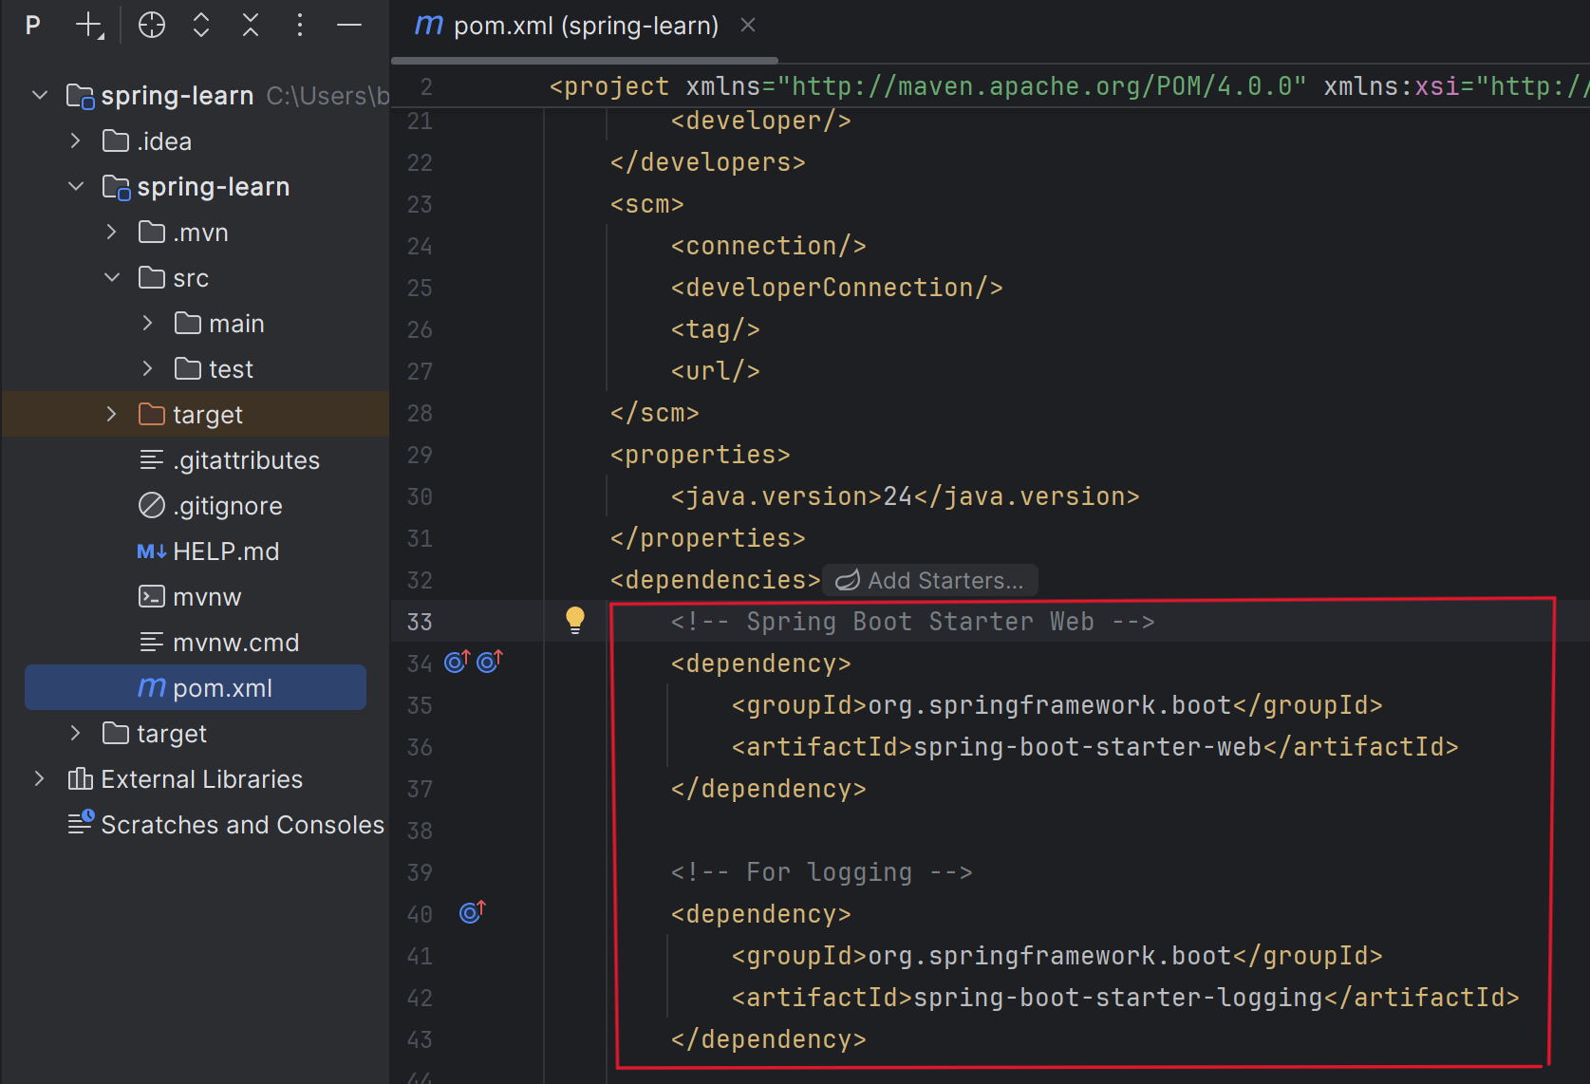**Step 1:** Making sure, all the **required dependencies are loaded** in our maven project in **pom.xml** file.

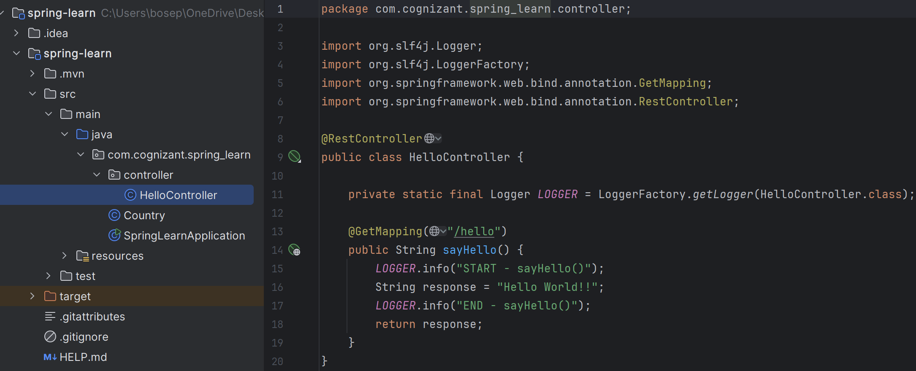 **Step 2**: Create the **HelloController** class

**Step 3**: **Change the port** to **8083:** just navigated tosrc/main/resources**/application.properties ,** and

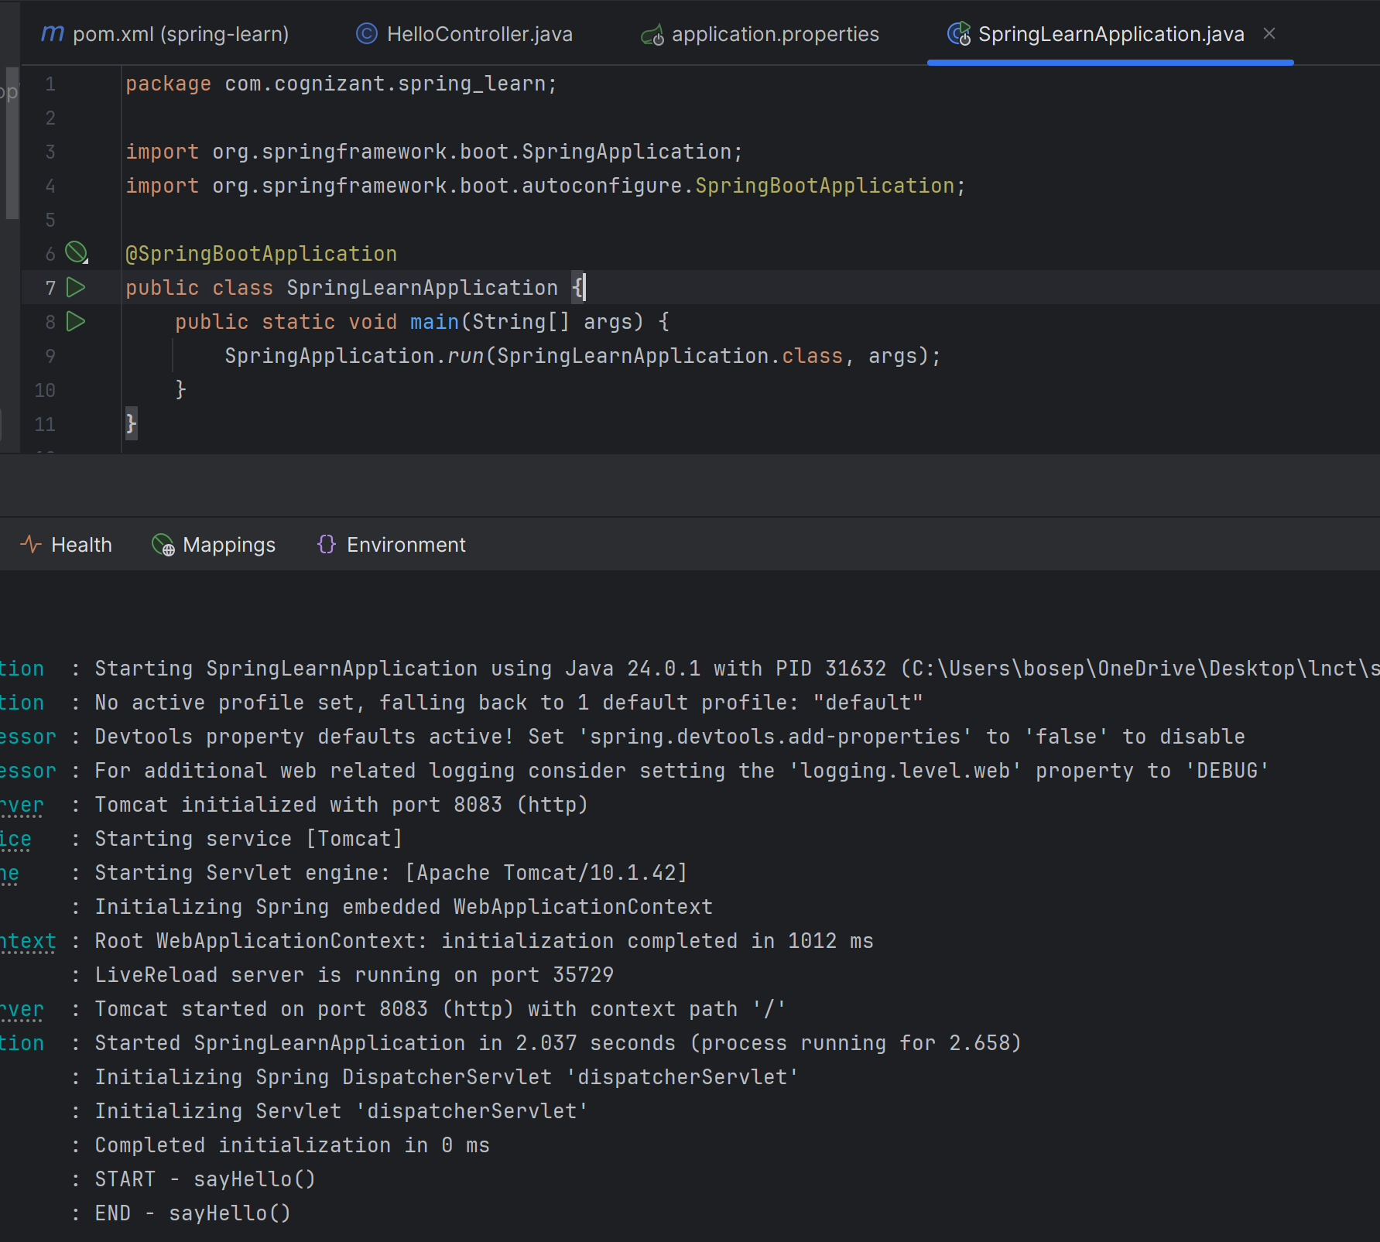 Wrote the code ---> **server.port=8083**

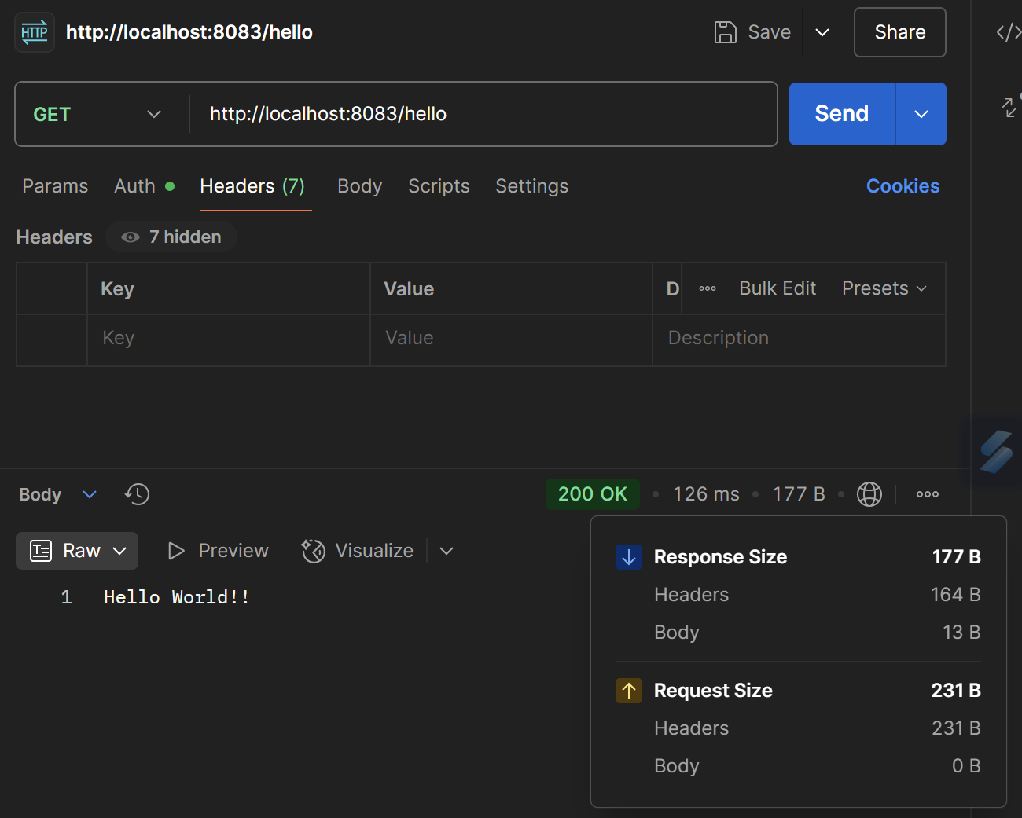**Step 4**: Run the application i.e. SpringLearnApplication ➜ **Run 'main'**

*******************************************************************************